

Healthmed Journal of Pharmaceutical Sciences

Journal Homepage: http://ps.healthmedsci.org/
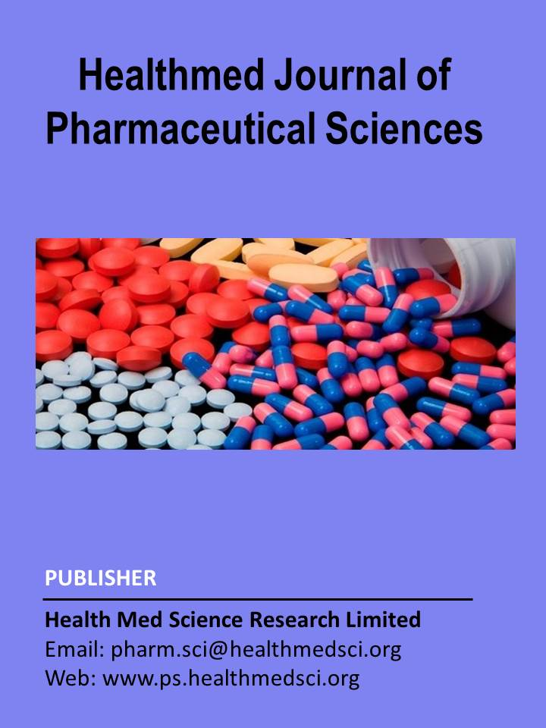

Research Article

Self-medication Practices in Bangladesh: A Comparative Cross-Sectional Study Between Urban and Rural Communities

Abstract

Self-medication (SM) is widely practiced in Bangladesh and constitutes a growing public health concern due to inappropriate medicine use and limited regulatory enforcement. Of particular concern is the misuse of prescription only medicines, including antibiotics, driven by decisions made without consultation from qualified healthcare practitioners. Evidence comparing determinants of self-medication between urban and rural populations remains limited. This study evaluated the prevalence and determinants of self-medication practices in Bangladesh, with a specific focus on decision making influenced by unqualified pharmacy dispensers and the misuse of antibiotics without professional supervision. A community based cross-sectional survey was conducted using a structured questionnaire administered through face-to-face interviews. A total of 530 respondents from urban and rural communities were included. Data were analyzed descriptively to assess sociodemographic characteristics, frequency of self-medication, sources of treatment decisions, indications for medicine use, and categories of drugs obtained without prescription. Self-medication, defined as the use of medicines without consultation with a registered physician within the preceding six months, was commonly reported, with most respondents indicating weekly or monthly practice. Decision making was largely influenced by advice from retail or community pharmacy dispensers who were not licensed medical practitioners, followed by reuse of old prescriptions and personal experience with similar illnesses. Higher educational attainment did not prevent self-medication and was associated with greater confidence in self-directed treatment decisions. Pain related conditions, febrile illness, and gastrointestinal complaints were the most common indications. A substantial proportion of respondents reported using prescription only medicines, including antibiotics, without physician consultation. Antibiotic misuse was significantly higher among rural respondents (68%) compared to urban respondents (32%), reflecting limited access to qualified healthcare providers and greater reliance on nonprofessional dispensers in rural communities. Self-medication in Bangladesh is driven primarily by nonprofessional treatment advice and inappropriate access to prescription medicines, including antibiotics. These practices pose significant risks for antimicrobial resistance and unsafe drug use. Strengthening regulation of pharmacy dispensing, restricting nonprescription antibiotic sales, and implementing targeted public health education are critical to promoting rational medicine use.

Keywords: Self-medication practices; Antibiotic misuse; Prescription-only medicines; Retail pharmacy dispensing; Urban rural comparison; Rational use of medicines; Bangladesh

Introduction

In recent years there has been an increasing trend in self-medication practice in both developed and developing countries (Ali et al.; 2012). Self-medication refers to the practice in which individuals select and use medicines to manage self-recognized symptoms or illnesses without consulting a qualified healthcare professional, including the intermittent or continued use of previously prescribed medicines without current medical supervision (WHO, 2000; Awad et al.; 2005; Zheng et al., 2023). Self-medication (SM) is a widespread and increasing practice worldwide and is considered a public health concern because it can lead to antibiotic resistance, harmful side effects, drug interactions, and delayed diagnosis of diseases (Baracaldo-Santamaría et al., 2022). Recent evidence from a systematic review and meta-analysis indicates that antibiotic self-medication remains highly prevalent worldwide, with an estimated pooled prevalence of approximately 43%. Marked differences across regions and considerable variability among studies further underscore the global and widespread misuse of antibiotics (Gashaw et al., 2025). The rational use of medicines means that patients receive medications that are appropriate for their clinical needs, in doses that meet their individual requirements, for an adequate period of time, and at the lowest possible cost to them and the community. When medicines are not used rationally, they may be prescribed, dispensed, or sold inappropriately, leading to poor treatment outcomes, adverse drug reactions, antimicrobial resistance, and unnecessary healthcare costs. The World Health Organization has highlighted that irrational medicine use remains a significant global health problem, particularly in low and middle income countries, and includes inappropriate self-medication with prescription only medicines (WHO, 2025). An emerging issue highlighted in recent literature is the increasing tendency of individuals to self-medicate for chronic health conditions, including hypertension, diabetes, and mental health disorders. Unlike the short-term management of minor symptoms, unsupervised use of medicines for long-term conditions carries a higher risk of inadequate disease control, adverse drug effects, and delayed recognition of complications. Evidence suggests that the continued reuse of previously prescribed medications for chronic illnesses is becoming more common, particularly in settings where access to regular medical follow-up is limited (Saha et al., 2023). At the global public health level, self-medication is increasingly recognized as a significant contributor to the antimicrobial resistance (AMR) problem. International health authorities and recent evidence syntheses have repeatedly highlighted the widespread use of antibiotics without prescription, particularly at the community level, as a major factor accelerating resistance. The continued prevalence of this behavior suggests that awareness-raising efforts alone are inadequate unless accompanied by stronger regulatory controls and improved access to appropriate healthcare services (WHO, 2025; Gashaw et al., 2025). Recent regional evidence indicates that differences between urban and rural settings play an important role in shaping self-medication practices. Individuals living in rural areas tend to depend more on self-medication because of constrained healthcare facilities, transportation difficulties, and the greater time and financial burden associated with seeking professional medical care. In contrast, urban residents often have easier access to a wide range of drug outlets, which may increase exposure to a greater variety of medicines and raise the risk of polypharmacy. Despite these distinct patterns, systematic investigation of urban rural differences in self-medication within Bangladesh remains limited (Osei-Tutu et al., 2024). In addition, the rapid expansion of digital health resources and loosely regulated online medicine vendors has further intensified self-medication practices by enabling direct access to drug-related information and products. Such autonomous medicine use frequently occurs without appropriate diagnostic evaluation, thereby increasing the likelihood of inadequate management of chronic health conditions. Strengthening regulatory oversight alongside targeted public education initiatives is therefore essential to promote patient safety and rational use of medicines (Mackey et al., 2016; Limbu et al., 2023). Furthermore, the role of non-professional medicine sellers and informal advisors remains underexplored in many settings, despite their significant influence on treatment decisions. Understanding these dynamics is essential for designing effective interventions aimed at promoting rational medicine use. The influence of pharmacies and easy access to medicines has been linked with higher self-medication practices in community settings (Chautrakarn et al., 2021). In Bangladesh, perceived convenience and medication knowledge have shown significant associations with self-medication behavior among university populations (Tohan et al., 2024). Table 1 summarizes commonly used prescription medicines involved in self-medication practices and highlights their intended therapeutic use along with associated safety concerns. The table illustrates that a wide range of drug classes including antibiotics, analgesics, acid-suppressing agents, and medications for chronic and acute conditions are frequently used without professional supervision, underscoring the potential public health risks associated with inappropriate self-medication.

Table 1. Common prescription medicines used for self-medication and associated safety concerns.
Self-medication Category | Common Examples | Intended Use | Potential Concern | Reference
Antibiotics | Amoxicillin, Azithromycin | Infections | Antimicrobial resistance | (Shah et al., 2014)
NSAIDs | Diclofenac, Naproxen | Inflammation, pain | GI bleeding, cardiovascular risk | (Krasniqi et al., 2024)
Cough & Common Cold Medicines | Codeine containing syrups, antihistamine & decongestant combinations | Cold, flu symptoms | Sedation, dependence | (Tian et al., 2025)
Vitamins & Minerals | Vitamin D (high dose), Iron, Zinc | Immunity, fatigue | Toxicity, organ damage | (Badr et al., 2022)
Acid-Suppressing Drugs | Pantoprazole | Acidity, GERD | Nutrient malabsorption, rebound acidity | (Häcker & Morck, 2012)
Antihistamines | Cetirizine, Loratadine | Allergy relief | Drowsiness, masking disease | (Idris et al., 2016)
Weight-Loss Drugs | Orlistat, Metformin | Weight management | GI effects, metabolic risk | (Abdalfattah et al., 2025)
Antidiarrheal / Antimicrobials | Metronidazole | Diarrhea | Masking infection, resistance | (Saha et al., 2023)
Prescription Analgesics | Tramadol | Moderate to severe pain | Dependence, organ toxicity | (Osei-Tutu et al., 2024)
Emergency Contraceptives | Ulipristal acetate | Unplanned pregnancy | Hormonal imbalance | (Barbian et al., 2021)
Ophthalmic Drops | Steroid antibiotic combinations | Eye infection | Glaucoma, resistance | (Alamer et al., 2023)

While self-medication has been widely studied globally, limited research compares self-medication practices between urban and rural populations in Bangladesh. Despite extensive research on self-medication, nationally comparative evidence examining urban rural differences in Bangladesh remains scarce. Existing studies primarily focus on specific cities or diseases, lacking a comprehensive evaluation of the socio-demographic factors and drug types involved in self-medication across different regions. The aim of this study is to compare self-medication practices between urban and rural populations in Bangladesh, focusing on prevalence, patterns, and socio-demographic influences. The objectives of this study were to assess the prevalence of self-medication among the general population in Bangladesh, to compare self-medication practices between urban and rural areas, to identify the common medicines and health conditions associated with self-medication, to examine the sources of information influencing self-medication behavior, and to evaluate the role of socio-demographic factors in shaping self-medication practices.

Materials and Methods
3.1 Study Design, Setting, and Population

This study was designed as a survey-based cross-sectional study to evaluate self-medication practices among the general population of Bangladesh. A total of 530 respondents, including both male and female participants from various age groups, were enrolled in the study. Data collection was conducted over a one-year period from November 2014 to October 2015. Participants were recruited from community settings without restriction to occupation, education level, or socioeconomic status. Participation was entirely voluntary, and all respondents were informed about the purpose and objectives of the survey prior to inclusion. The study was carried out across 15 districts representing diverse geographic and sociodemographic backgrounds, including Dhaka, Chattogram, Madaripur, Munshiganj, Narayanganj, Faridpur, Shariatpur, Patuakhali, Comilla, Noakhali, Barisal, Khulna, Rajshahi, Rangpur, and Sylhet. Selection of these locations considered population diversity, accessibility, and time feasibility. Participants were recruited using a non-probability convenience sampling approach, which was adopted due to logistical constraints. Recruitment was conducted in community settings, including residential neighbourhoods, local marketplaces, and areas surrounding retail pharmacies within the selected districts. The sampling frame consisted of adult community residents present in the selected locations during the data collection period. Inclusion criteria were individuals aged 15 years and above who resided in the selected urban or rural areas and were willing to participate. Exclusion criteria included individuals unwilling to provide consent or unable to complete the interview due to illness or communication difficulties. Participants were approached directly by trained data collectors using a face-to-face interview method. The study purpose was explained prior to participation, and verbal informed consent was obtained. Refusal to participate was low, and no personal identifiers were recorded. To reduce potential selection bias, data collection was conducted across multiple districts, on different days and times, and included both urban and rural settings to capture a diverse range of sociodemographic characteristics.

3.2 Data Collection Instrument and Procedure

Data were collected using a structured questionnaire designed to obtain information on sociodemographic characteristics, patterns of self-medication, indications for self-medication, sources of information, and types of medicines used. The questionnaire was reviewed for clarity and consistency prior to data collection. In this study, self-medication was defined as the use of any medicine, including prescription-only medicines, without consultation with a qualified medical practitioner. This included direct purchase of medicines from retail pharmacies without a prescription, reuse of previously prescribed medicines without current medical advice, and medicine use based on personal experience or advice from nonprofessional sources. In this study, the term misuse was defined as the use of any prescription-only medicine without consultation with a registered physician. This includes antibiotics and other prescription-only drug categories. Antibiotics were analyzed as a key subgroup due to their public health importance. The assessment of misuse was limited to non-prescription access and unsupervised use and did not include evaluation of dosing accuracy, treatment duration, or clinical appropriateness of indication. Self-medication practice was assessed by asking participants the following question: “Have you used any medicine without consulting a registered physician in the past six months?” Respondents who answered affirmatively were further asked about the frequency of self-medication, which was categorized as weekly, monthly, or occasional use. The six-month recall period was selected to balance recall accuracy with the need to capture habitual self-medication behaviour. Participants were approached voluntarily, and the purpose of the study was explained prior to administering the questionnaire. The study was conducted in accordance with ethical principles for research involving human participants. Verbal informed consent was obtained from all respondents before data collection. Participation was voluntary, and anonymity and confidentiality of participants’ information were strictly maintained throughout the study.

3.3 Data Analysis

All collected data were checked for completeness and consistency before analysis. Data were entered and analyzed using Microsoft Excel (Microsoft Corp., USA). Descriptive statistics were used to summarize frequencies and percentages. Chi-square (χ²) tests were applied to examine associations between categorical variables, including sociodemographic factors and self-medication practices. A p-value of less than 0.05 was considered statistically significant.

3.4 Ethical considerations

This study was conducted as part of a master’s dissertation under the Department of Pharmacy, East West University, Bangladesh. At the time of data collection (2014-2015), formal institutional review board (IRB) approval numbers were not routinely issued for non-interventional, community-based survey studies conducted as academic theses at the departmental level during the study period. The study protocol, questionnaire, and informed consent procedures were reviewed at the departmental level under the supervision of the academic supervisor prior to data collection.

The study was conducted in accordance with internationally accepted ethical principles for research involving human participants, including the Declaration of Helsinki. Participation was entirely voluntary, verbally informed consent was obtained from all respondents before data collection, and no personal identifiers were recorded. Anonymity and confidentiality of participant information were strictly maintained throughout the study.

Results

Distribution of Sociodemographic Characteristics of the Respondents

The study population consisted of respondents of varying ages, gender, and residential backgrounds. Male participants predominated, and most respondents belonged to the economically active age group. A higher proportion of participants were married, and representation from both urban and rural areas was comparable. Overall, the sample reflected a diverse sociodemographic profile suitable for evaluating self-medication practices.

Table 2. Sociodemographic characteristics of respondents with chi-square analysis (n = 530)
Variable | Category | Frequency (n) | Percentage (%) | χ² value | p-value
Gender | Male | 435 | 82.0 | 218.11 | <0.001
Gender | Female | 95 | 18.0
Place of Residence | Urban | 281 | 53.0 | 1.93 | 0.165
Place of Residence | Rural | 249 | 47.0
Age Group (years) | 15–30 | 276 | 52.0 | 238.75 | <0.001
Age Group (years) | 31–60 | 244 | 46.0
Age Group (years) | >60 | 10 | 2.0
Marital Status | Married | 339 | 64.0 | 316.46 | <0.001
Marital Status | Unmarried | 186 | 35.0
Marital Status | Widowed/Divorced | 5 | 1.0
Monthly Income (BDT) | 0–5000 | 196 | 37.0 | 110.11 | <0.001
Monthly Income (BDT) | 5001–15000 | 170 | 32.0
Monthly Income (BDT) | 15001–30000 | 127 | 24.0
Monthly Income (BDT) | >30000 | 37 | 7.0
Educational Status | Illiterate | 117 | 22.0 | 128.82 | <0.001
Educational Status | Primary | 32 | 6.0
Educational Status | Secondary | 191 | 36.0
Educational Status | University | 190 | 36.0
Occupation | Employed | 334 | 63.0 | 286.29 | <0.001
Occupation | Unemployed | 180 | 34.0
Occupation | Retired | 16 | 3.0

Chi-square tests were used to assess whether the observed distributions of sociodemographic variables differed significantly across categories.

Table 3. Prevalence and frequency of self-medication among respondents (n = 530)
Frequency of self-medication | Urban (n=281) n (%) | Rural (n=249) n (%) | Total (N=530) n (%)
Weekly | 171 (60.9) | 78 (31.3) | 249 (47.0)
Monthly | 95 (33.8) | 138 (55.4) | 233 (44.0)
≥ Once every 6 months | 15 (5.3) | 33 (13.3) | 48 (9.0)
Total | 281 (100.0) | 249 (100.0) | 530 (100.0)
Chi-square test for residence vs frequency: χ² = 47.66, df = 2, p < 0.001.
Self-medication was common within the preceding six months. Weekly use was more prevalent among urban respondents, while monthly and ≥ once every six months use was more frequent in rural areas (Table 3; χ² = 47.66, p < 0.001).

Table 4. Framework of the self-medication Decision Process among Respondents
Step | Component | Key Contributor
Step 1 | Frequency of practice | Regular use (weekly or monthly)
Step 2 | Motivation for self-medication | Perceived minor or simple illness
Step 3 | Information pathway | Retail pharmacy
Step 4 | Reinforcing factor | Previous experience with similar conditions
The decision-making process underlying self-medication is summarized in Table 4. Self-medication was primarily driven by the perception of illness as minor and prior experience with similar conditions, with retail pharmacies serving as the main source of information. Previous prescriptions and advice from family or friends also influenced decisions, while formal sources such as drug information leaflets and mass media played a minimal role.
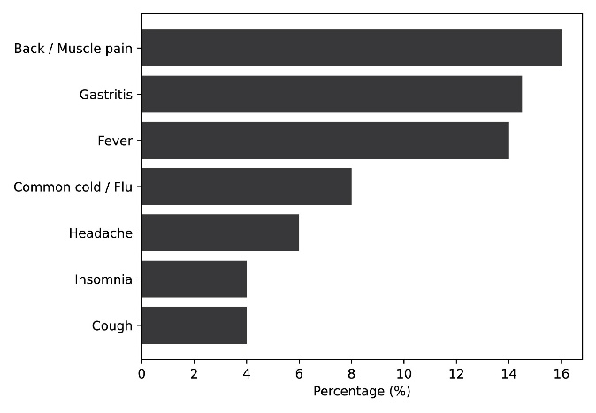

Figure 1: Major indications for self-medication among the study population. Back or muscle pain was the most frequently reported indication, followed by gastritis and fever, while conditions such as headache, insomnia, and cough were reported less frequently.

The distribution of health conditions for which self-medication was practiced differed between urban and rural populations. To better understand these variations, the most frequently reported indications were analyzed comparatively. Figure 2 presents the leading indications for self-medication in urban and rural areas, highlighting differences in the pattern and prevalence of commonly reported conditions between the two settings.
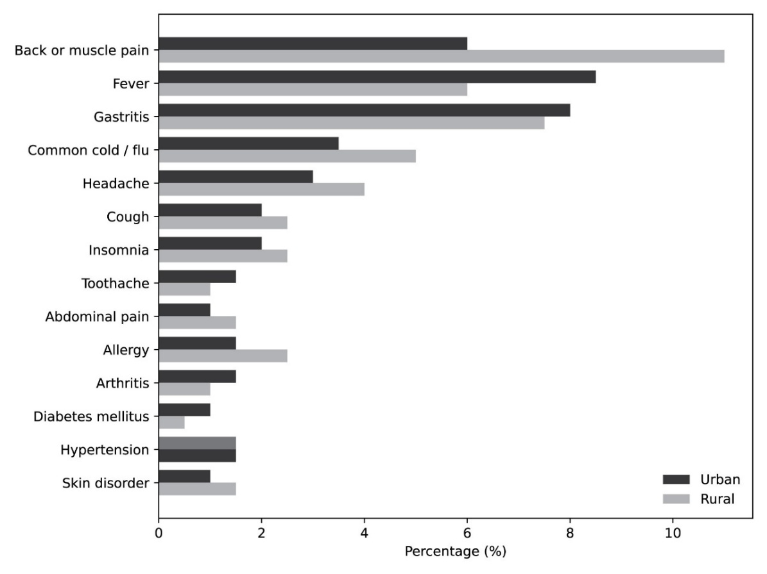
Figure 2: Comparative Indications for self-medication in Urban and Rural Areas (Top 14). The comparative analysis of indications for self-medication shows clear differences between urban and rural populations. Back or muscle pain was the most common indication in rural areas, while fever and gastritis were more frequently reported in urban settings. Rural respondents showed higher self-medication practices for common cold, headache, insomnia, and allergy, whereas urban respondents demonstrated relatively greater use for fever, gastritis, and toothache. Overall, rural populations relied more on self-medication for pain-related and common illnesses, while urban populations showed higher use for gastrointestinal and febrile conditions.

Table 5. Medicine Groups Used for Self-medication (n = 530)
Medicine group | Number of respondents (n) | Percentage (%)
Proton pump inhibitors | 121 | 22.8
Non-steroidal anti-inflammatory drugs (NSAIDs) | 119 | 22.5
Antibiotics | 76 | 14.3
Cough preparations | 67 | 12.6
Antihistamines | 65 | 12.3
H2 blockers | 29 | 5.5
Antacids | 14 | 2.6
Vitamins | 14 | 2.6
Topical skin preparations | 14 | 2.6
Anti-diabetic drugs | 12 | 2.3
Antihypertensive drugs | 11 | 2.1
Eye drops | 11 | 2.1
Antidiarrheals / antiprotozoal agents | 11 | 2.1
Sedatives | 6 | 1.1
Antiemetics | 6 | 1.1
Steroids | 5 | 0.9
Herbal preparations | 4 | 0.8
Bronchodilators | 2 | 0.4
Antispasmodics | 2 | 0.4
Antifungal drugs | 1 | 0.2

Comparative analysis of medication use between urban and rural respondents demonstrates a consistently higher tendency toward self-medication among individuals residing in rural areas for most medicine groups. Antibiotic use was notably higher in the rural population compared to the urban population, indicating a greater reliance on antibiotics without prescription in rural settings. A similar pattern was observed for non-steroidal anti-inflammatory drugs (NSAIDs), where rural respondents showed higher usage than their urban counterparts. Proton pump inhibitors and H2 blockers were also more frequently used in rural areas, suggesting increased self-management of gastrointestinal symptoms among rural respondents. Antihistamines and cough preparations followed the same trend, with rural usage exceeding urban usage, reflecting a higher prevalence of self-treatment for allergic and respiratory conditions in rural communities.
In contrast, urban respondents showed relatively comparable or slightly higher use of certain medications such as eye drops, topical skin preparations, and vitamins; however, the overall differences remained modest. Less frequently used medication groups including antidiabetic drugs, antihypertensives, antispasmodics, bronchodilators, and antifungal agents were reported at low levels in both settings, though rural use remained marginally higher in most categories.
Overall, the findings indicate that rural populations exhibit a greater inclination toward self-medication across multiple therapeutic categories, particularly for antibiotics, NSAIDs, and acid-suppressing drugs, compared to urban populations. A higher proportion of antibiotic self-medication was observed among rural respondents than urban respondents (68% vs. 32%), with chi-square analysis indicating a significant association between place of residence and antibiotic use (p < 0.05).
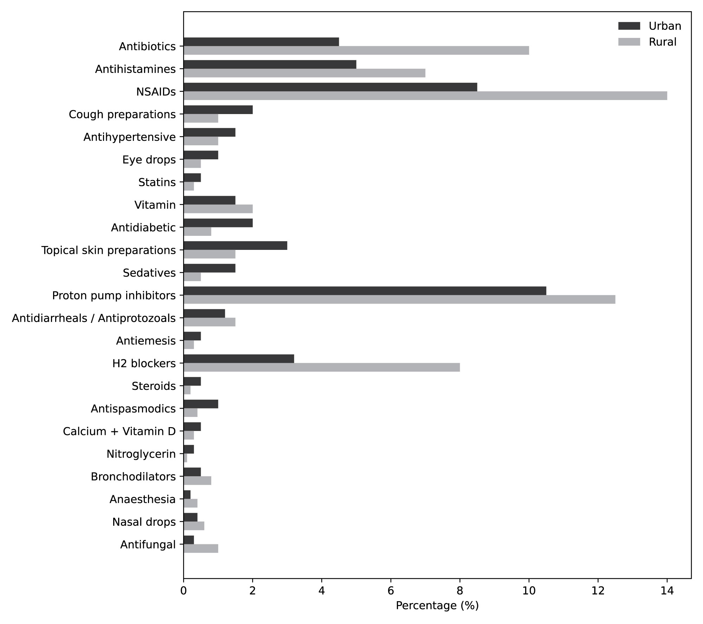
Figure 3: Comparative distribution of self-medicated drug categories in urban and rural populations. The percentage distribution of commonly self-medicated drug categories among urban and rural respondents. Higher use of antibiotics, NSAIDs, and proton pump inhibitors was observed in rural areas compared to urban areas. Urban respondents showed relatively lower but comparable use across most medication groups. The findings highlight notable rural and urban differences in self-medication practices, particularly for analgesics and gastrointestinal medications.

Discussion
Comparing results of this study with those of other studies conducted in other countries seems somewhat difficult due to differences in cultures, health care systems, and the roles of community pharmacies. This study found that male respondents practiced self-medication to a larger extent than females, which may partly reflect greater male availability in public and community settings where the survey was conducted, as well as men’s more visible role in medicine purchasing from retail pharmacies. This result is consistent with the findings of another study (Jasim et al., 2014) and contradicts other studies (Carrasco et al., 2009; Chua et al., 2011).

This study indicated that about 98% of the study population were 15-60 years old, which seems logical since individuals in this age group have a greater ability than older individuals to move and seek medications, due to fewer incidences of joint or cardiovascular diseases compared to older people (Kaye et al., 2010; Lakatta, 2002; North et al., 2012).

In this study, most respondents were married, which may be attributed to religious and traditional considerations that encourage marriage at younger ages.

About two-thirds of the study population ranked their monthly income as less than good. This result is consistent with other studies conducted in developing countries, which found that the majority of the population practicing self-medication belonged to a low economic status group (Worku et al., 2003).

This study demonstrated that about 71% of respondents were literate. This could be explained by the increasing percentage of educated individuals in the general population.

The primary reason mentioned by 41% of respondents for practicing self-medication was the perception of having a simple ailment that did not require physician consultation. This finding is consistent with another study, which showed that patients’ perception of their current conditions as simple illnesses was the dominant factor behind self-medication practices (James et al., 2008).

The second most common reason for practicing self-medication among nearly two-thirds of the study population was prior experience and knowledge of treatment from similar previous ailments. This may be explained by individuals’ ability to remember medications, whether prescribed or over-the-counter (OTC), used for similar previous conditions, especially when such medications were effective in improving symptoms (Widayati et al., 2011).

The most important source of information for self-medication reported in this study was retail dispensers, who are licensed to sell medicines but not to prescribe them.

The second most important source was previous prescriptions, which were reused without re-consultation. Friends and family members who had suffered from similar conditions were also identified as important sources of information. The study showed that some conditions treated through self-medication were minor and did not require physician consultation; however, other conditions required medical supervision for appropriate evaluation and treatment.

Pain (17%), fever (15%), and gastritis (15%) were the main indications for self-medication. However, some critical conditions, such as diabetes mellitus and hypertension, were also treated through self-medication, which require proper medical consultation and supervision.

Respondents used a wide range of drug classes for self-medication. Some of these drugs were available over the counter and could be dispensed based on patient requests, while others were prescription only medications that should be used under physician supervision. In the context of this study, misuse specifically denotes the use of prescription only medicines without physician consultation and does not encompass incorrect dosing, treatment duration, or clinical appropriateness of indication, which were not assessed. Approximately 14% of the study population reported using antibiotics without prescription. Among antibiotic users, 32% were from urban areas, whereas 68% were from rural areas. This higher use in rural areas may reflect limited access to healthcare facilities and delayed physician consultation. Additionally, the use of sedatives (5%) and cough preparations (2%) raises concerns regarding potential misuse. The self-medication use of antidiabetic (2%) and antihypertensive drugs (3%), often sourced from retail dispensers or previous prescriptions, also poses significant health risks.

Study Limitations

This study has certain limitations. The data were self-reported and therefore subject to recall bias. The cross-sectional design limits causal interpretation. Additionally, the study was conducted in selected districts, which may limit the generalizability of the findings to the entire population of Bangladesh. The predominance of male respondents may further limit generalizability, particularly with respect to self-medication practices among women, and should be considered when interpreting the results. Although data were collected earlier, the findings remain relevant due to persistent self-medication practices and ongoing regulatory challenges in Bangladesh.

Conclusion and Future Direction

This study demonstrates that self-medication is a widespread practice among the general population of Bangladesh, occurring in both urban and rural communities. The findings indicate that self-medication is most prevalent among individuals aged 15–60 years and is strongly influenced by perceptions of illness as minor, previous treatment experience, and advice obtained from retail pharmacy dispensers. Despite relatively high literacy levels among respondents, inappropriate self-medication practices persisted, including the use of prescription only medicines such as antibiotics, sedatives, antihypertensive, and antidiabetic drugs without professional consultation. A notable rural urban disparity was observed, with rural populations exhibiting higher reliance on antibiotics and other prescription medicines, likely reflecting limited access to qualified healthcare services and greater dependence on nonprofessional dispensers. The predominant use of analgesics, acid-suppressing drugs, and antibiotics raises significant public health concerns, particularly regarding antimicrobial resistance, drug misuse, and delayed diagnosis of chronic diseases. Overall, the findings highlight gaps in regulatory enforcement, public awareness, and pharmacy practice that contribute to unsafe medication behaviors.

Future efforts should focus on strengthening regulatory control over the dispensing of prescription-only medicines, particularly antibiotics, through stricter enforcement of existing drug laws and enhanced monitoring of retail pharmacy practices. Capacity building and formal training for retail pharmacy dispensers are essential to promote rational medicine use and appropriate referral to qualified healthcare professionals.

Public health education campaigns targeting both urban and rural populations should be implemented to improve awareness of the risks associated with inappropriate self-medication, especially for chronic and infectious diseases. Further research using longitudinal and intervention-based study designs is recommended to assess causal factors and evaluate the effectiveness of policy and educational interventions. Integrating pharmacists more effectively into primary healthcare services and expanding access to affordable medical consultation, particularly in rural areas, may play a critical role in reducing unsafe self-medication practices in Bangladesh.

List of Abbreviations
(List all the abbreviations appeared in your manuscript as given below)
SM: Self-medication, OTC: Over the Counter, NSAIDs: Non-Steroidal Anti-Inflammatory Drugs, PPI: Proton Pump Inhibitor, H2 blocker: Histamine 2 Receptor Antagonist, GERD: Gastroesophageal Reflux Disease, WHO: World Health Organization, BDT: Bangladeshi Taka, GI: Gastrointestinal

Conflicts of Interest
The authors declare that the research was conducted in the absence of any commercial or financial relationships that could be construed as a potential conflict of interest.

Author Contributions Statement (State the contributions of each author as given below)

Conceptualization: BMS conceptualized and designed the study. BMS, ZI, MNR, and FA were responsible for data collection, including prescription review and participant interviews. MKM, MR, and UA contributed to data organization and initial manuscript drafting. BMS conducted critical review, editing, and overall supervision of the manuscript. Final manuscript preparation and approval were carried out by BMS, ZI, MNR, and FA. NN provided project supervision and methodological guidance. All authors read and approved the final version of the manuscript.

Funding Information (mention the funding sources if you have received any financial support)

This research received no external funding.

Acknowledgements

The authors would like to express their sincere gratitude to all healthcare professionals, including medical doctors, pharmacists, nurses, and other healthcare workers, for their dedication and commitment in providing healthcare services despite professional challenges and psychological stress. The authors are also thankful to all study participants for their voluntary participation and for providing valuable information and prescriptions that contributed significantly to the completion of this study.

Data Availability Statement
Data relevant to the study is already included in the article or attached in the supplements. Raw data will be provided upon reasonable request by contacting the corresponding author.

References (Follow this Vancover/NCBI Reference style with DOI number as provided below)

Abdalfattah, Nouralhoda Ahmed, et al. “Knowledge and Practice about Non-Prescription Weight Loss Supplements Utilization among University Students.” International Journal of Adolescent Medicine and Health, Sept. 2025. PubMed, https://doi.org/10.1515/ijamh-2025-0124.
Alamer, Sarah S., et al. “Ophthalmic Self-medication Practices and Associated Factors of Using Steroid Eye Drops Among Adult Ophthalmic Patients.” Cureus, vol. 15, no. 8, Aug. 2023, p. e43110. PubMed, https://doi.org/10.7759/cureus.43110.
Ali, Abdul Nazer, et al. “Self-medication Practices among Health Care Professionals in a Private University, Malaysia.” International Current Pharmaceutical Journal, vol. 1, no. 10, Sept. 2012, pp. 302–10. www.banglajol.info, https://doi.org/10.3329/icpj.v1i10.11846.
Awad, Abdelmoneim, et al. “Self-medication with Antibiotics and Antimalarials in the Community of Khartoum State, Sudan.” Journal of Pharmacy & Pharmaceutical Sciences: A Publication of the Canadian Society for Pharmaceutical Sciences, Societe Canadienne Des Sciences Pharmaceutiques, vol. 8, no. 2, Aug. 2005, pp. 326–31. PubMed.
Badr AF, Alghamdi L, Baraidah H, Alsulami R. Prevalence and patterns of self-medication during COVID-19 pandemic amongst pharmacy students in Jeddah, Saudi Arabia: cross-sectional study. Saudi J Clin Pharm. 2022;1(4):112–117. doi:10.4103/sjcp.sjcp_6_22.
Baracaldo-Santamaría, Daniela, et al. “Definition of Self-medication: A Scoping Review.” Therapeutic Advances in Drug Safety, vol. 13, Oct. 2022, p. 20420986221127501. PubMed Central, https://doi.org/10.1177/20420986221127501.
Barbian, Julia, et al. “Emergency Contraception in University Students: Prevalence of Use and Knowledge Gaps.” Revista De Saude Publica, vol. 55, 2021, p. 74. PubMed, https://doi.org/10.11606/s1518-8787.2021055003076.
Carrasco-Garrido, P., et al. “Patterns of Medication Use in the Immigrant Population Resident in Spain: Associated Factors.” Pharmacoepidemiology and Drug Safety, vol. 18, no. 8, Aug. 2009, pp. 743–50. PubMed, https://doi.org/10.1002/pds.1776.
Chua SS, Sabki NH. Use of nonprescription medications by the general public in the Klang Valley. J Appl Pharm Sci. 2011;1(09):93–98. Available from: https://www.japsonline.com/admin/php/uploads/268_pdf.pdf.
Gashaw, Tigist, et al. “The Global Prevalence of Antibiotic Self-medication among the Adult Population: Systematic Review and Meta-Analysis.” Systematic Reviews, vol. 14, no. 1, Feb. 2025, p. 49. Springer Link, https://doi.org/10.1186/s13643-025-02783-6.
Häcker, Franziska, and Hartmut Morck. “Self-medication of Upper Gastrointestinal Symptoms with Hydrotalcite: A Noninterventional Community Pharmacy Study on Drug Usage and Patient Satisfaction.” International Journal of Clinical Pharmacology and Therapeutics, vol. 50, no. 2, Feb. 2012, pp. 87–99. PubMed, https://doi.org/10.5414/cp201576.
Idris T, Khanum S, Uddin MS, Asaduzzaman M, Islam MA, Nasrin F, Haider SS. Study on self-medication practices among university students of Bangladesh. J Adv Med Med Res. 2016;14(6):1–8. doi:10.9734/BJMMR/2016/24364.
James, H., et al. “Influence of Medical Training on Self-medication by Students.” International Journal of Clinical Pharmacology and Therapeutics, vol. 46, no. 1, Jan. 2008, pp. 23–29. PubMed, https://doi.org/10.5414/cpp46023.
Jasim, Ali L., et al. “Self Medication Practice among Iraqi Patients in Baghdad City.” American Journal of Pharmacological Sciences, vol. 2, no. 1, Jan. 2014, pp. 18–23. pubs.sciepub.com, https://doi.org/10.12691/ajps-2-1-4.
Kaye, Alan D., et al. “Pain Management in the Elderly Population: A Review.” Ochsner Journal, vol. 10, no. 3, 2010, pp. 179–87. PubMed.
Krasniqi, Gentiana, et al. “Excessive Self-medication with Prescription NSAIDs: A Cross-Sectional Study in Kosovo.” Pharmacy (Basel, Switzerland), vol. 12, no. 3, June 2024, p. 93. PubMed, https://doi.org/10.3390/pharmacy12030093.
Lakatta, Edward G. “Age-Associated Cardiovascular Changes in Health: Impact on Cardiovascular Disease in Older Persons.” Heart Failure Reviews, vol. 7, no. 1, Jan. 2002, pp. 29–49. Springer Link, https://doi.org/10.1023/A:1013797722156.
Limbu, Yam B., and Bruce A. Huhmann. “Illicit Online Pharmacies: A Scoping Review.” International Journal of Environmental Research and Public Health, vol. 20, no. 9, May 2023, p. 5748. DOI.org (Crossref), https://doi.org/10.3390/ijerph20095748.
Mackey, Tim K., and Gaurvika Nayyar. “Digital Danger: A Review of the Global Public Health, Patient Safety and Cybersecurity Threats Posed by Illicit Online Pharmacies.” British Medical Bulletin, vol. 118, no. 1, June 2016, pp. 110–26. DOI.org (Crossref), https://doi.org/10.1093/bmb/ldw016.
North, Brian J., and David A. Sinclair. “The Intersection between Aging and Cardiovascular Disease.” Circulation Research, vol. 110, no. 8, Apr. 2012, pp. 1097–108. PubMed, https://doi.org/10.1161/CIRCRESAHA.111.246876.
Osei-Tutu, Solomon, et al. “Patterns and Social Factors Associated with Non-Prescription Use of Tramadol: A Cross-Sectional Study among Youth in Urban Informal Settlements in Ghana.” Journal of Health, Population, and Nutrition, vol. 43, no. 1, Nov. 2024, p. 191. PubMed, https://doi.org/10.1186/s41043-024-00688-z.
Saha, Ayan, et al. “Prevalence and Determinants of Self-medication Practices among general Population: A Cross-Sectional Study in Thimphu, Bhutan and Chattogram, Bangladesh.” Journal of Public Health Research, vol. 12, no. 1, Jan. 2023, p. 22799036231152327. PubMed Central, https://doi.org/10.1177/22799036231152327.
Shah, Syed Jawad, et al. “Self-medication with Antibiotics among Non-Medical University Students of Karachi: A Cross-Sectional Study.” BMC Pharmacology and Toxicology, vol. 15, no. 1, Dec. 2014, p. 74. Springer Link, https://doi.org/10.1186/2050-6511-15-74.
Tian, Yu-Shi, et al. “Status and Influencing Factors of OTC Medicine Use for Self-medication in Cold and Cough: A Cross-Sectional Survey in Japan.” BMC Public Health, vol. 25, no. 1, May 2025, p. 1918. PubMed, https://doi.org/10.1186/s12889-025-23113-4.
Tohan, Mortuja Mahamud, et al. “Knowledge Attitude and Convenience on Self-medication Practices among University Students in Bangladesh Exploration Using Structural Equation Modeling Approach.” Scientific Reports, vol. 14, no. 1, May 2024, p. 10837. www.nature.com, https://doi.org/10.1038/s41598-024-60931-9.
Widayati, Aris, et al. “Self Medication with Antibiotics in Yogyakarta City Indonesia: A Cross Sectional Population-Based Survey.” BMC Research Notes, vol. 4, Nov. 2011, p. 491. PubMed, https://doi.org/10.1186/1756-0500-4-491.
Worku, Solomon, and Abebe G/Mariam. “Practice of Self-medication in Jimma Town.” The Ethiopian Journal of Health Development, vol. 17, no. 2, 2003. ejol.aau.edu.et, https://ejol.aau.edu.et/index.php/EJHD/article/view/2300.
World Health Organization. Antimicrobial Resistance. https://www.who.int/news-room/fact sheets/detail/antimicrobial-resistance. Accessed 18 Dec. 2025.
World Health Organization. Guidelines for the regulatory assessment of medicinal products for use in self-medication. Geneva: World Health Organization; 2000. Available from: https://iris.who.int/server/api/core/bitstreams/452f183c-812d-4f3a-a841-6910268cf785/conten.
World Health Organization. Promoting Rational Use of Medicines. https://www.who.int/activities/promoting-rational-use-of-medicines. Accessed 18 Dec. 2025.
Zheng, Yu, et al. “A Systematic Review of Self-medication Practice during the COVID-19 Pandemic: Implications for Pharmacy Practice in Supporting Public Health Measures.” Frontiers in Public Health, vol. 11, 2023, p. 1184882. PubMed, https://doi.org/10.3389/fpubh.2023.1184882.

