
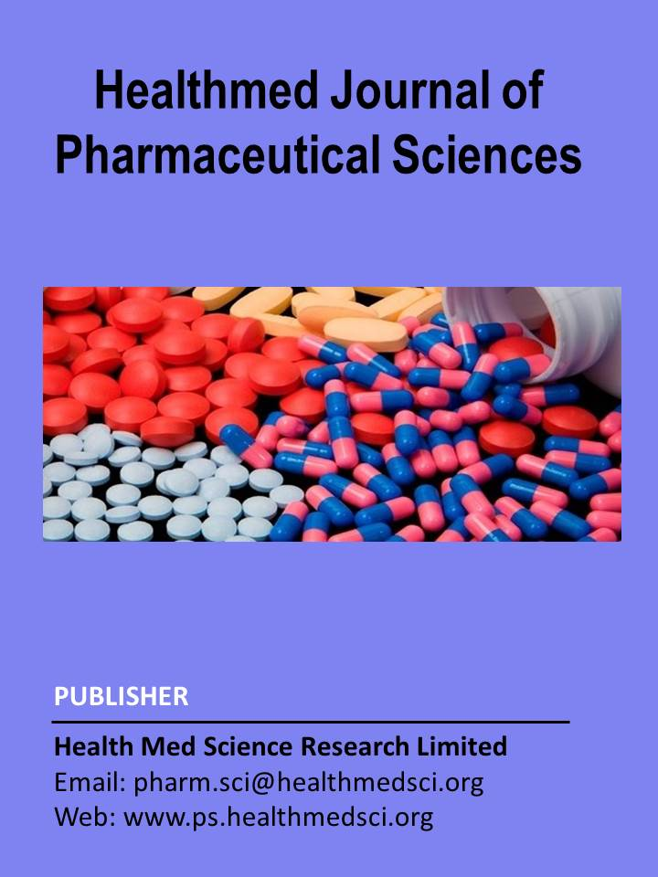

Healthmed Journal of Pharmaceutical Sciences

Journal Homepage: http://ps.healthmedsci.org/

Research Article
Analgesic, CNS depressant and antibacterial activities of ethanol extract of Spilanthes paniculata leaves
Md. Khalequeuzzaman,* Sadia Islam, Mst. Mahfuza Khatoon, Anik Kumar Dey

Department of Pharmacy, Gono Bishwabidyalay, Mirzanagar, Savar, Dhaka, Bangladesh

Abstract
Spilanthes paniculata Wall. is an important medicinal plant which is used to treat toothache, throat and gum infections. The present study was aimed to investigate the analgesic, CNS depressant and antibacterial activities of the ethanol extract of Spilanthes paniculata leaves. Analgesic activity was determined by formalin and acetic acid induced writhing method, however CNS depressant activity was determined by open field and hole cross test. Antimicrobial activity was evaluated by disk diffusion method. In acetic acid induced writhing method, the SPE showed significant writhing inhibition 66.92% (p<0.01) at a dose of 500 mg/kg body weight as compared to control .In formalin test, the SPE (500mg/kg) showed a significant licking inhibition 46.77% (p<0.01) In CNS depressant activity, test animals showed significant decrease (p<0.001) in number of movement with the treatment of SPE (500mg/kg) Diazepam (1mg/kg) was used as standard drug. SPE at the dose of 800µg/disc showed moderate antibacterial activity against most of the gram positive and gram negative bacteria.Thus our study suggests that ethanol extract of Spilanthes paniculata may be a source of natural product having its analgesic and CNS depressant activities along with moderate antibacterial activity.

Keywords: Spilanthes paniculata, Ethanol extract, Analgesic, CNS depressant, Antibacterial.

* Correspondence: Md. Khalequeuzzaman, Associate Professor, Department of Pharmacy, Gono Bishwabidyalay (University), Nolam, Mirzanagar, Savar, Dhaka 1342, Bangladesh); Email: email: sobujph@gmail.com; Phone: +8801924865471

Introduction
The empirical use of plants as medicine can be traced back to over five millennia to ancient documents to early civilizations, such as in china, Egypt, India and the near east, but is certainly as old as mankind (Balick MJ, Cox PA 2020). Many of the plants used in antiquity as medicines still play an important role for health today (Miraldi M and Baini G 2019). The use of the medicinal plant is increasing in many countries where one third of drugs contain natural products.
Spilanthes paniculata belongs to Asteraceae family is a small tender annual that grows to about 12-15 inches and will spread to 24-30 inches which is native to the Americas and has been introduced to Asia, Africa, the Pacific islands, and Australia. The most common and widespread medicinal use for Spilanthes paniculata is to treat toothache, throat and gum infections. A mouth rinse of spilanthes extract can be used daily to promote gum health, and chewing as little as a single bud of the plant can numb the mouth and reduce the pain of toothache for up to 20 minutes depending on the sensitivity of the person (Pathak et al 2013). The leaves of Spilanthes paniculata possesses antioxidant activity (Haque et al. 2015) and also have Antidiabetic and thrombolytic effects (Akter et al 2014).

The role of free radicals can be found in the inflammatory process which is a complex process resulting many human diseases (Biswas S et al 2017). Pain is formally defined as an unpleasant sensory and emotional incident coupled with real or likely tissue injure. Pain acts as a word of warning sign against disorder of the body and has a practical function.

Analgesic mitigates pain as a symptom without affecting its reason (Akter et al 2009). However, data from multiple placebo-controlled trials and meta-analyses studies alarmingly signify the adverse effects of NSAIDs in gastrointestinal, cardiovascular, hepatic, renal, cerebral and pulmonary complications (Bindu S et al 2020). As a result more and more people are turning to herbal medicines as the alternative treatment of pain.

Anxiety disorders are often comorbid with one another and with other mental disorders, especially depression, as well as with somatic disorders. Such comorbidity generally signifies more severe symptoms, greater clinical burden, and greater treatment difficulty (Penninx BW et al 2021). Notably, benzodiazepines and drugs based on neurotransmitter systems are currently being used to treat anxiety. However, ineffective treatment, undesirable effects and dependence still exist in many cases. The CNS depressant effect of herbs has been paid more and more attention gradually because of increasing incidence of anxiety and predominance of traditional herbs in therapy.

Antimicrobial agents are essentially important in reducing the global burden of infectious diseases (Bhatia et al 2010). However, emergence and dissemination of multidrug resistant (MDR) strain in pathogenic bacteria have become a significant public health threat as there are fewer, or even sometimes no, effective antimicrobial agents available for the infection caused by pathogenic bacteria (Giamarellou et al 2010). A vast number of medicinal plants have been recognized as valuable resources of natural antimicrobial compounds as an alternative that can potentially be effective in the treatment of these problematic bacterial infections.

In order to explore the potential biological activity of the ethanol extract of Spilanthes paniculata leaves we studied analgesic, CNS depressant and antibacterial activity.

Materials and Methods

Chemicals

All the chemicals and reagents were used for this study was analytical grade from Merck Germany and Sigma Aldrich (USA). The standard drug Diazepam was collected from the Square Pharmaceuticals Ltd, Bangladesh.

Plant Material

The leaves of Spilanthes paniculata are collected from Dhamrai Dhaka, Bangladesh and was identified by the department of Botany, Jahangirnagar University, Savar, Dhaka, Bangladesh. Immediately after collection the leaves were thoroughly washed with water. Then the leaves were dried under shade for 2 days and were ground to coarse powder with a mechanical grinder. The powder was extracted individually with ethanol and ether in a Soxhlet apparatus. The mixture was filtered and the filtrate was concentrated by Rota evaporator to yield semisolid mass. The extracts were preserved in refrigerator till further use.

Experimental animals

Swiss albino mice of both sexes, aged 5-6 weeks, weighting about 20-30 gm were purchased from the department of Pharmacy of Jahangirnagar University, Savar, Dhaka, Bangladesh. Before initiating the experiment, the mice were kept in standard environmental conditions having temperature at 22.0±2.0°C, relative humidity at 55-65% and 12 h light/12 h dark cycle and had free access to feed and water ad libitum. The animals were acclimatized to laboratory condition for one week prior to experiments

Ethical approval of experiment protocol

All protocols for animal experiment were approved by the ethical review board of Gono Bishwabidyalay.

Evaluation of in-vivo analgesic activity

Acetic acid induced writhing test

Acetic acid induced writhing method is an analgesic behavioral observation assessment method that demonstrates a noxious stimulation in mice. The experiment was carried out as described by Sharma et al 2010. Fifty mg of crude ethanol extracts are triturated by the addition of small amount of suspending agent (Tween 80). Normal saline (0.9% NaCl) was slowly added to make the final volume up to 2.5ml. To prepare the standard, indomethacin 10 mg was dissolved into 0.9% normal saline and made the volume up to 10 ml. The control solution, tween 80 (1%) was mixed properly in the normal saline to make the volume up to 5 ml. The test samples, control (1% tween 80 in water) and standard (indomethacin) were administered orally with the help of a feeding needle at the beginning or the experiment. After 30 minutes, 0.7% acetic acid was injected intra-peritoneally to each of the animals of all the groups to create pain sensation. Then the animals were placed on an observation table. Approximately 5 minutes after the injection of acetic acid, a wave of contraction and elongation of abdominal musculature referred to as writhing is started and the number of writhing for the next 10 minutes were counted for each rat. Full writhing was not always accomplished by the animal, because sometimes the animals started to gibe writhing but they did not complete it. This incomplete writhing is considered as half-writhing. Accordingly, two half-writhing was considered as one full writhing. The number of writhes in each treated group was compared to that o f a control group while indomethacin (10 mg/kg) was used as a reference substance (positive control). The percent inhibition (% analgesic activity)was calculated by the following equation:

% inhibition =[((A-B))/A] ×100

Where,

A= Average number of writhing of control per group

B= = Average number of writhing of test per group

Formalin induced hind paw licking test

The analgesic activity of the drugs was determined using the formalin test as described by Sharma et al 2010. Fifty mg of crude ethanol extract of Spilanthes paniculata was triturated by the addition of small amount of suspending agent. Normal saline (0.9% NaCl) was slowly added to make the final volume up to 2.5 ml. To prepare the standard, indomethacin 10 mg was dissolved into 0.9% normal saline and made the volume up to 10 ml. For preparing control sample, distilled water was mixed properly in the normal saline to make the volume up to 5 ml. The test samples, control (distilled water 10 ml/kg) and standard (indomethacin 10 mg/kg) are administered orally with the help of a feeding needle at the beginning of the experiment. After 30 minutes, 0.05ml of 2.5% formalin (40% formaldehyde) in distilled water is injected into the dorsal surface of the right hind paw of the mice. Then the mice are individually placed in transparent cage observation chamber. The time spent licking the injected paw is recorded and the data were expressed as total licking time in the early phase (0-5 min) and the late phase (15-30 min) after formalin injection. The percent inhibition (%licking activity) is calculated by the following equation:

% inhibition =[((A-B))/A] ×100

Where, A= Average number of licking of control per group

B= Average number of licking of test per group

Central nervous system (CNS) depressant activity

Hole cross method

The most consistent behavioral change is a hyperemotional response to novel environmental. The experiment was carried out as described by Munira MS et al 2019. The experiment was carried out to characterize the emotional behavior of mice using the hole-board test. The mice are divided into control, standard control and test group. The test groups receive ethanol extract of leaves of Spilanthes paniculata at the dose of 250 and 500 mg/kg body weight orally whereas control group receive vehicle (1% Tween 80 in water) at 10ml/kg body weight orally and standard group receive diazepam at the dose of 1 mg/kg body weight orally with the help of a feeding needle at the beginning of the experiment. A steel partition is fixed in the middle of a cage having a size of 30×20×14 cm. A hole of 3cm diameter is made at a height of 7.5cm in the center of the cage. The number of passages of a rat through the hole from one chamber to other is counted for a period of 3 min on 0, 30, 60, 90 and 120min after oral administration of test drugs.

Open field method

This experiment is carried out as described by Sultana T et al 2018. The open field test is clearly the most frequently used of all behavioral tests in pharmacology and neuroscience. The mice are divided into control, standard and test group. The test groups receive ethanol extract of leaves of Spilanthes paniculata at the dose of 250 and 500 mg/kg body weight orally whereas control group receive vehicle (1% Tween 80 in water) at 10ml/kg body weight orally and standard group received diazepam at the dose of 1mg/kg body weight orally with the help of a feeding needle at the beginning of the experiment. The floor of an open field of half square meter is divided into a series of squares each alternatively colored black and white. The apparatus has 40 cm height a wall. The number of square visited by the animals was counted for 3 min, on 0, 30, 60, 90 and 120 min after oral administration of standard and sample.

Anti-bacterial Activity

Antibacterial activity of the ethanol extracts of leaves of Spilanthes paniculata was determined by disc diffusion technique (Ngamsurach P and Praipipat P 2022). To determine the antibacterial activity of ethanol extract two gram-positive (Staphylococcus aureus, Bacillus cereus) and two gram-negative (Escherichila coli, Pseudomonas aeruginosa,) bacteria were used. For comparison kanamycin-K (30 µgm per disc) was used as standard. Nutrient agar media was reconstituted with distilled water in a conical flask according to specification (2.3%). It was then heated in water bath to dissolve the agar until a clear solution of agar was obtained. The media prepared was then transferred in 20ml and 5ml to prepare plates and slants respectively in a number of clean test tubes. The slants were used for making sub-culture of microorganism which in turn were used for sensitivity tests. The tubes were then plugged with cotton and sterilized in an autoclave at a temperature of 121°C and a pressure of 151 Ib/sq. inch for 20 minutes. The test organisms were transferred from the pure culture to the agar slants with the help of an inoculating loop in an aseptic condition. The inoculated slants were then incubated at 37°C for 18-24 hours to assure the growth of the test organisms. This culture was then used within one week. With the help of an inoculating loop, the test organism was transferred from the subculture to the test tube containing 20 ml autoclaved media in an aseptic area. Then The test tube was shaken well by rotation to get a uniform suspension of organism. The bacterial suspensions were immediately transferred to the sterile petridishes in such a way as to obtain a uniform depth of media (approximately 4mm thick). The petridishes were rotated several times, first clockwise and then anti-clockwise to assure homogenous distribution of the test organisms. The plates were cooled to room temperature and it was stored in a refrigerator (4°C). After that the test sample and standard discs were prepared carefully at concentration of 800µg/disc and 30µgm/discs respectively. The Prepared discs were placed gently on the freshly seeded solidified agar plates with a sterile forceps. Standard discs and controlled discs were also placed on the test plates. The spatial arrangements of the discs were such that the discs were not closer than 15mm to the edge of the plates to prevent overlapping the zone of inhibition. The plates were then inverted and kept in a refrigerator for about 1244 hours at 4°C to obtain maximum diffusion. Finally the plates were incubated at 37°C for 12-18 hours. After incubation, the antibacterial activities of the test samples were determined by measuring the diameter of inhibitory zones in terms of millimeter (mm).

Results
Determination of analgesic activity
Analgesic activity of Spilanthes paniculata leaves by Acetic acid-induced writhing test
In acetic acid induced writing test, the ethanol extract of Spilanthes paniculata leaves significantly and dose dependently suppress the frequency of acetic acid-induced writhing in mice after oral administration. At 500 mg/kg body weight, SPE showed 66.92% of writhing inhibition whereas at 10 mg/kg body weight, the standard drug indomethacin showed 60% of writhing inhibition.
Table1: Analgesic activity of Spilanthes paniculata leaves by Acetic acid-induced writhing test
Treatment Group | Dose (body weight) | Mean no. of writhing | % of inhibition
1% Tween 80 in water (control) | 1 ml/10 gm | 32.50±8.74 | -
Indomethacin (standard) | 10 mg/kg | 13.00±3.65** | 60
SPE | 250 mg/kg | 16.50±5.19* | 49.23
SPE | 500 mg/kg | 10.75±2.99** | 66.92
All the values are stated as Mean ± SD. (Where, n=4); significance level ***p<0.001, **p<0.01, *p<0.05 compared to control.
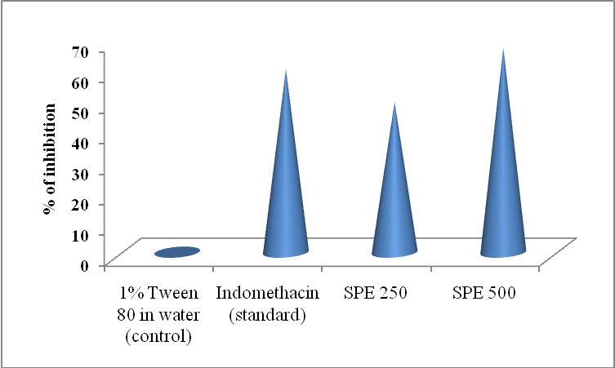
Figure-1: Analgesic activity of Spilanthes paniculata leaves by Acetic acid-induced writhing test

Analgesic activity of Spilanthes paniculata leaves by Formalin induced pain test
The ethanol extract of leaves of Spilanthes paniculata significantly suppressed the licking activity in the formalin-induced pain in mice in a dose dependent manner. The standard drug (Indomethacin) used in the experiment showed 37.10% licking inhibition with a dose of 10 mg/kg of body weight whereas SPE showed 46.77% licking inhibition with a dose of 500mg/kg of body weight.

Table2: Analgesic activity of Spilanthes paniculata leaves by Formalin induced pain test
Treatment Group | Dose (body weight) | Mean number of licking | % of inhibition
Distilled water (control) | 10 ml/kg | 31.00±7.96 | -
Indomethacin (standard) | 10 mg/kg | 19.50±1.29* | 37.10
SPE | 200 mg/kg | 21.50±2.08* | 30.64
SPE | 500 mg/kg | 16.50±3.42** | 46.77
All the values are stated as Mean ± SD. (Where, n=4); significance level ***p<0.001, **p<0.01, *p<0.05 compared to control.
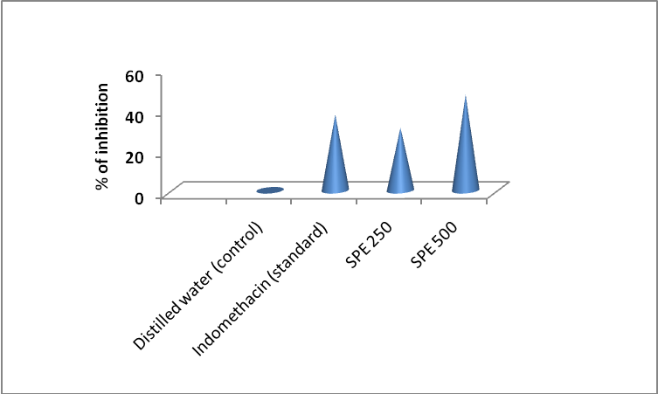
Figure-2: Analgesic activity of Spilanthes paniculata leaves by Formalin induced pain test
CNS depressant activity determination
CNS depressant activity of Spilanthes paniculata leaves by hole cross test
The animal treated with different doses of ethanol extract of Spilanthes paniculata leaves showed dose dependent reduction in the locomotor activity and it was comparable with that of standard drug diazepam. The extract produced reduction in spontaneous motor activity, and this effect may be attributed to CNS depression, as depression of locomotor activity is common to most neuroleptics.

Table 3: CNS depressant activity of Spilanthes paniculata leaves by hole cross test
Treatment Group | Dose (body weight) | No. of movements
Treatment Group | Dose (body weight) | 0 min | 30 min | 60 min | 90 min | 120 min
1% tween 80 in water (control) | 10ml/kg | 12.75±0.96 | 13.50±2.38 | 13.75±2.21 | 9.25±4.57 | 12.00±2.58
Diazepam (standard) | 1 mg/kg | 9.25±0.96** | 7.75±1.25** | 6.75±1.26*** | 4.25±1.50 | 3.00±1.41***
SPE | 250 mg/kg | 11.25±0.96 | 10.75±1.89 | 7.75±0.96 | 6.75±1.26 | 5.75±0.50*
SPE | 500 mg/kg | 9.50±0.96** | 4.25±0.96*** | 2.75±0.96*** | 2.00±0.82** | 1.50±0.57***
All the values are stated as Mean ± SD. (Where, n=4); significance at ***p<0.001, **p<0.01, *p<0.05 as compared to control

CNS depressant activity of Spilanthes paniculata leaves by Open field test
Open field test was carried out to determine the depressive action of the test samples. In this test, the extract showed a noticeable dose dependent decrease in locomotion in the test animals. Test animals showed significant decrease in number of movement at dose 500 mg/kg after 120 min compared to standard.
Table4: CNS depressant activity of Spilanthes paniculata leaves by Open field test
Treatment Group | Dose (body weight) | No. of movements
Treatment Group | Dose (body weight) | 0 min | 30 min | 60 min | 90 min | 120 min
1% tween 80 in water (control) | 10ml/kg | 62.50±9.34 | 57.50±6.75 | 55.25±6.23 | 51.75±4.03 | 49.00±5.47
Diazepam (standard) | 1 mg/kg | 55.00±7.26 | 25.00±4.96*** | 12.25±2.98*** | 10.50±2.38*** | 5.00±2.61***
SPE | 250 mg/kg | 82.75±3.77 | 74.00±5.97** | 58.50±8.10 | 47.25±7.88 | 34.25±6.34*
SPE | 500 mg/kg | 58.25±7.50 | 28.50±2.88*** | 15.75±2.06*** | 9.75±1.71*** | 4.75±0.96***
All the values are stated as Mean ± SD. (Where, n=4); significance at ***p<0.001, **p<0.01, *p<0.05 as compared to control.

Anti-bacterial activity
Evaluation of the antimicrobial activity of the ethanol extract of Spilanthes paniculata was determined initially by the disc diffusion method against different microorganisms. These organisms were frequently encountered in infectious diseases. It was observed that the extract used in the study exhibited a varying degree of antibacterial activity against all microorganisms tested.

Table5: Antibacterial activity of Spilanthes paniculata leaves by disk diffusion method.
Bacteria |  | Diameter of the zone of inhibition (mm)
 |  | SPE  800 µg/disc. | Kanamycin-K  30 µg/disc.
Gram Positive | Staphylococcus aureus | 16 | 25
Gram Positive | Bacillus cereus | 9 | 26
Gram Negative | Pseudomonas  aeruginosa | 6 | 20
Gram Negative | Esherichia coli | 8 | 22

Discussion

Scientific and methodical investigation of herbal plants has become a potential source for the discovery of lead compounds of high therapeutic value in terms of analgesic activity. Ethno-pharmacological studies have become increasingly invaluable in the development of modalities for the management of pain and related disorders. Thus green pharmaceuticals have now received considerable attention and popularity in this area due to its availability, less side effects and economic feasibility compared to the orthodox medicine. In this study, the ethanol extract of the Spilanthes paniculata leaves showed significant analgesic activity (p< 0.01) at a dose of 500 mg/kg body weight compared to standard indomethacin. So the leaves of this plant can be a source of further investigation for discovery and development of analgesic drug.
Central nervous system (CNS) depressants are drugs that can be used to slow down brain activity. CNS depressants may be prescribed by a physician to treat anxiety, muscle tension, pain, insomnia, acute stress reactions, panic attacks, and seizure disorders. CNS depression often results from the use of depressant drugs such as alcohol, opioids, barbiturates, benzodiazepines, general anesthetics etc. Drug overdose is often caused by combining two or more depressant drugs, although overdose is certainly possible by consuming a large dose of one depressant drug. In this study the ethanol extrac of the Spilanthes paniculata leaves showed significant CNS depressant activity (p< 0.001) at a dose of 500 mg/kg body weight compared to standard diazepam. So further more specific investigation on this leaves may reveal the opportunity to discover and development of CNS depressant drug from this plant.
In the light of the evidence of the rapid global spread of antibiotic resistant bacterial strains, the need to find new antimicrobial agents is of paramount importance. Plants are rich in a wide variety of secondary metabolites such as tannins, alkaloids, phenolic compounds, and flavonoids, which have been found in vitro to have antimicrobial properties. In this study the ethanol extrac of the Spilanthes paniculata leaves showed moderate antibacterial activity against Staphylococcus aureus among the four bacterial strains compared to standard Kanamycin.

Conclusion and Future Direction

This study revealed that the leaf extract of Spilanthes paniculata possesses good analgesic and CNS depressant activity. The plant extract also has moderate antibacterial activity. Further more specific studies may confirm the analgesic and CNS depressant potential of this plant which could open a new window on the use of this plant in traditional medicine.

List of Abbreviations
SPE: Ethanol extract of Spilanthes paniculata, SD: Standard Deviation, CNS: Central Nervous System

Conflicts of Interest
The authors declare that the research was conducted in the absence of any commercial or financial relationships that could be construed as a potential conflict of interest.

Author Contributions Statement

M. Khalequeuzzaman and M. Khatoon designed the study protocol and S. Islam collected the plant. M. Khalequeuzzaman, M. Khatoon and S. Islam performed the experiments. Anik Kumar Dey contributed to data analysis.

Funding Information

This research received no external funding.

Acknowledgements

Authors are grateful to the department of Pharmacy, Gono Bishwabidyalay in where this research work was conducted.

Data Availability Statement
Data relevant to the study is already included to the article or attached in the supplements. Raw data will be provided on reasonable request upon contacting with the corresponding.

References

Akter R, Hasan SMR, Siddiqua SA, Majumder MM, Hossain MM, Alam MA, et al. Evaluation of analgesic and antioxidant potential of the leaves of Curcuma alismatifolia Gagnep. S. J. Pharm. Sci; 2009 ; 1&2: 3-9. DOI: http//doi.org/10.3329/sjps.v1i1.1779
Akter S, Rahman MA, Azad MAK, Mohiuddin M, Mamun AA, Sarker J et al. Antidiabetic and thrombolytic effects of ethanol extract of Spilanthes paniculata leaves. Journal of Plant Sciences; 2014; 2(6-1): 13-18. DOI: 10.11648/j.jps.s.2014020601.13
Balick MJ, Cox PA.Plants, People, and Culture: the Science of Ethnobotany, Scientific American Library; 2020; New York, U.S.A. DOI: 10.4324/9781003049074
Bhatia R and Narain JP. Thegrowing challenge of antimicrobial resistance in the South-East Asia Region - are we losing the battle. Indian Journal of Medical Research; 2010; 132(5), 482–486. DOI:10.4103/0971-5916.73313

Bindu S, Mazumder S, Bandyopadhyay U. Non-steroidal anti-inflammatory drugs (NSAIDs) and organ damage: A current perspective. Biochem Pharmacol; 2020;1:;180. DOI: 10.1016/j.bcp.2020.114147
Biswas S, Das R and Banerjee ER. Role of free radicals in human inflammatory diseases. AIMS Biophysics; 2017; 4(4): 596-614. DOI: 10.3934/biophy.2017.4.596

Giamarellou H. Multidrug-resistant Gram-negative bacteria: how to treat and for how long. International Journal of Antimicrobial Agents; 2010; vol. 36, Supplement 2, pp. S50–S54. DOI: https://doi.org/10.1016/j.ijantimicag.2010.11.14

Haque S, Lopa SD, Das BK. Evaluation of antioxidant potential of Spilanthes paniculata. Int J Pharm Pharm Sci; 2015; 7(8): 390-392. doi: https://journals.innovareacademics /6703/6893

Miraldi M and Baini G. MEDICINAL PLANTS AND HEALTH IN HUMAN HISTORY: FROM EMPIRICAL USE TO MODERN PHYTOTHERAPY. JOURNAL OF THE SIENA ACADEMY OF SCIENCES; 2019, 10(1). DOI: 10.4081/jsas.2018.8529

Munira MS, Ahmed SN, Islam MS, Nesa ML and Kabir MH. Pharmacological Screening for CNS Depression, Analgesic and Anti-inflammatory Potentials of Sonneratia caseolaris (Linn.) Barks in Different Solvent Fraction. Journal of Pharmaceutical Research International; 2019; 29(5); 1-11. DOI: 10.9734/jpri/2019/v29i530251
Ngamsurach P and Praipipat P. Antibacterial activities against Staphylococcus aureus and Escherichia coli of extracted Piper betle leaf materials by disc diffusion assay and batch experiments. ROYAL SOCIETY OF CHEMISTRY; 2022, 12, 435-454. DOI: 10.1039/D2RA04611C
Pathak K. Herbal medicine- A Rational Approach in Health Care System. International Journal of Herbal Medicine. 2013; 1(3): 86-89.
Penninx BW, Pine DS, Holmes EA and Reif A. Anxiety disorders. The Lancet; 2021; 397(10277), 914-927. DOI: 10.1016/S0140-6736(21)00359-7
Sharma A, Bhatial S, Kharyaz MD, Gajbhiye V, Ganesh N, Namdeo AG et al. Anti-inflammatory and analgesic activity of different fractions of Boswellia serrata. Int J Phytomed; 2010; 2: 94-99. DOI: 10.5138/ijpm.2010.0975.0185.02015
Sultana T, Mannan MA, and Ahmed T. Evaluation of central nervous system (CNS) depressant activity of methanolic extract of Commelina diffusa Burm. in mice. International Journal of Phytomedicine and Phytotherapy; 2018; 4(5). DOI: 10.1186/s40816-018-0063-1

