

Healthmed Journal of Pharmaceutical Sciences

Journal Homepage: http://ps.healthmedsci.org/
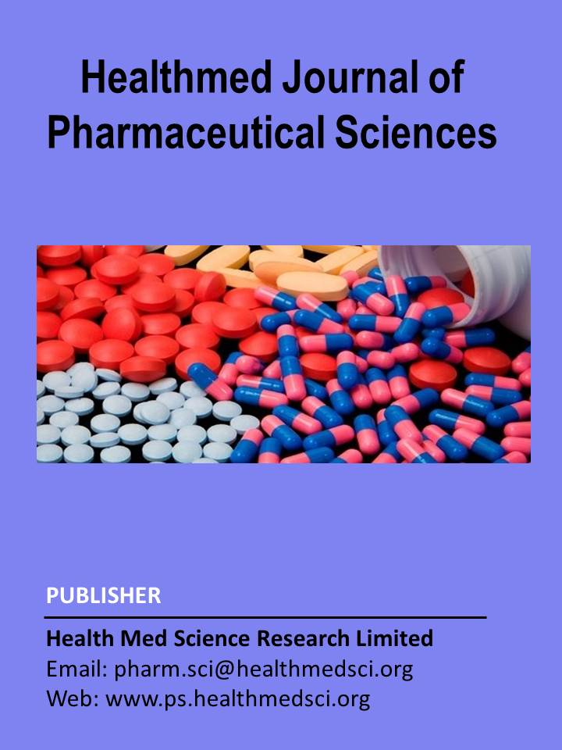

Review Article

Asparagus racemosus (Shatavari): From Traditional Medicine to Modern Therapeutics

Ali Asgher Raju¹, Baudrul Mohammad Shahjalal^{2*}, A K M Nuruzzaman Laskar³, S M Tanjim Hossain⁴, Al Amin Akash⁵

- ¹Department of Biomedical Engineering, Gannon University,109 University Square, Erie, PA, 16541, United States of America;
- ²Department of Biomedical Engineering, University of Mississippi, Oxford 38677, Mississippi, United States of America;
- ³Department of Computer and Information Science, Gannon University,109 University Square, Erie, PA, 16541, United States of America;
- ⁴School of Engineering and Computing, Gannon University,109 University Square, Erie, PA, 16541, United States of America;
- ⁵Department of Computer Science, La Roche University,9000 Babcock Boulevard, Pittsburgh, PA 15237, United States of America;

* Correspondence: Name (Baudrul Mohammad Shahjalal), Designation (Research Assistant), Affiliation (Department of Biomedical Engineering, University of Mississippi, Oxford, Mississippi, United States of America); Email: bshahjal@go.olemiss.edu; Phone: +18592703773

Short title: hatavari: Traditional to Modern Therapeutics

