

Healthmed Journal of Pharmaceutical Sciences

Journal Homepage: http://ps.healthmedsci.org/
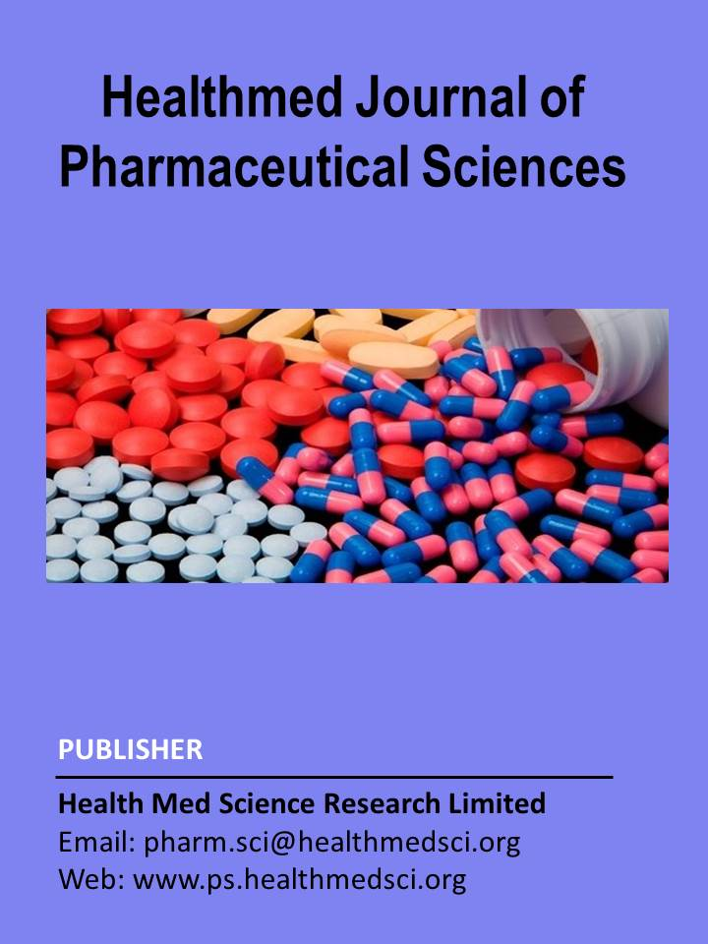

Research Article (Mention Review or Research Article)

Self-Medication Practices in Bangladesh: A Comparative Cross Sectional Study Between Urban and Rural Communities
(Over write your manuscript title on the above texts)

Baudrul Mohammad Shahjalal^{1,2*}, Md Naimur Rahman⁴, Farzana Akter⁶, Zinia Islam³, Md Kauser Miah⁵, Milan Rai², Utsab Acharya², Nishat Nasrin¹
(Write full authors name above and affiliations below as provided sample)

- ¹Department of Pharmacy, East West University, A, 2 Jahurul Islam Ave, Dhaka 1212, Bangladesh;
- ²Department of Biomedical Engineering, University of Mississippi, Oxford 38677, Mississippi, United States of America;
- ³ Department of Pharmacy, Northern University Bangladesh, Ashiyan City Rd, Dhaka 1230, Bangladesh;
- ⁴Biochemistry and Molecular Biology, Tejgaon College, 16 Indira Rd, Dhaka 1215, Bangladesh;
- ⁵Computer and Information Science Department, Gannon University,109 University Square, Erie, PA, 16541, United States of America;
- ⁶Computer Science and Software Engineering, Stamford University Bangladesh, 51 Siddheswari Rd, Dhaka 1217, Bangladesh;

* Correspondence: Name (Baudrul Mohammad Shahjalal), Designation (Research Assistant), Affiliation (Department of Biomedical Engineering, University of Mississippi, Oxford, Mississippi, United States of America); Email: bshahjal@go.olemiss.edu; Phone: +18592703773 (provide corresponding author information)

Short title: Self Medication Practices in Bangladesh

This page is known as Title page

